**DAILY ONLINE ACTIVITIES SUMMARY**

|  |  |  |  |  |  |  |  |  |
| --- | --- | --- | --- | --- | --- | --- | --- | --- |
| **Date:** | 17/06/2020 | | | | | **Name:** | SHREEKIRAN R BHAT | |
| **Sem & Sec** | IV Sem & B section | | | | | **USN:** | 4AL18CS080 | |
| **Online Test Summary** | | | | | | | | |
| **Subject** | | **-** | | | | | | |
| **Max. Marks** | | 30 | | **Score** | | | **-** | |
| **Certification Course Summary** | | | | | | | | |
| **Course** | Introduction to Information Security | | | | | | | |
| **Certificate Provider** | | | Great learning academy | | **Duration** | | | 5.5 hours |
| **Coding Challenges** | | | | | | | | |
| Problem Statement1: Write a C Program to Count numbers that don’t contain 3. | | | | | | | | |
| **Status:** Executed | | | | | | | | |
| **Uploaded the report in Github** | | | | | YES | | | |
| **If yes Repository name** | | | | | Lockdown-coding | | | |
| **Uploaded the report in slack** | | | | | YES | | | |

**Online Test Summary:** No internals conducted today.

**Online Certification Course Summary**: Today I have learnt about Introduction to Software Security and also learnt how to prevent SQL injection and also about client state manipulation.

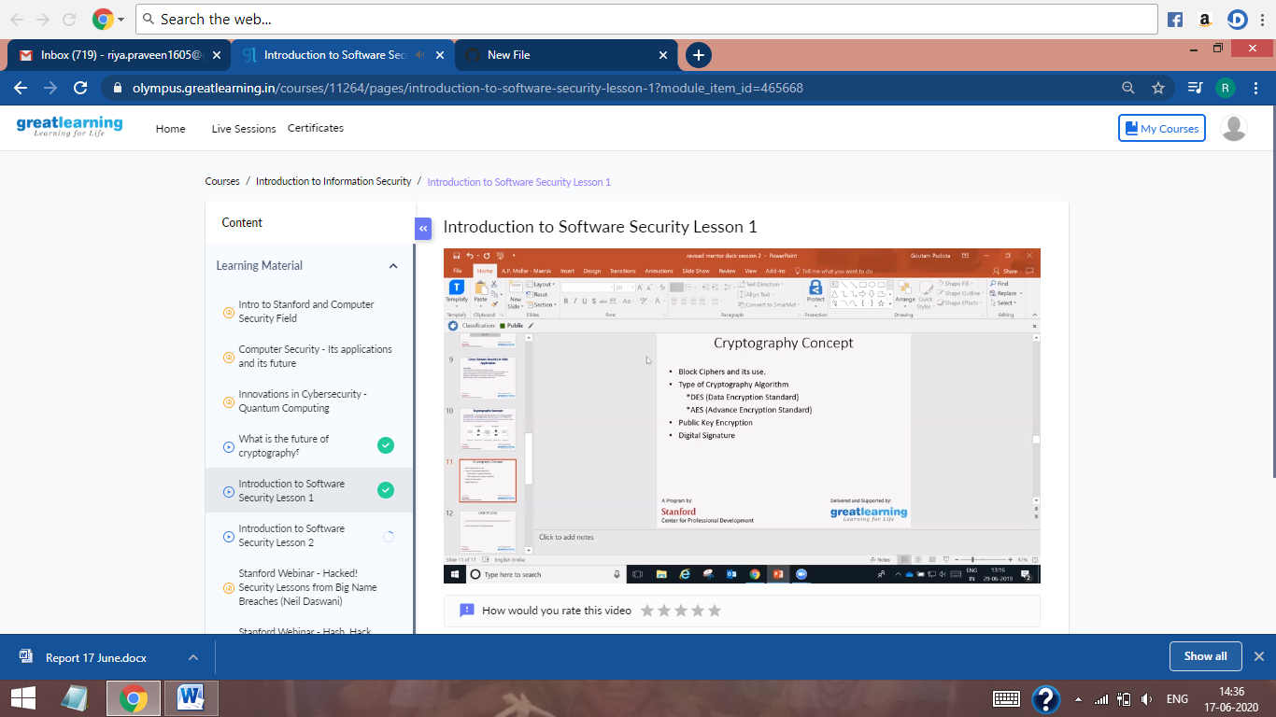

This is the Snap Shot of today’s session.

**Online Coding Summary:** Today I had received one program from prof. Shilpa CSE Dept. The program is mentioned above in the coding challenges (pg.01). I have also uploaded it to my Github repository.

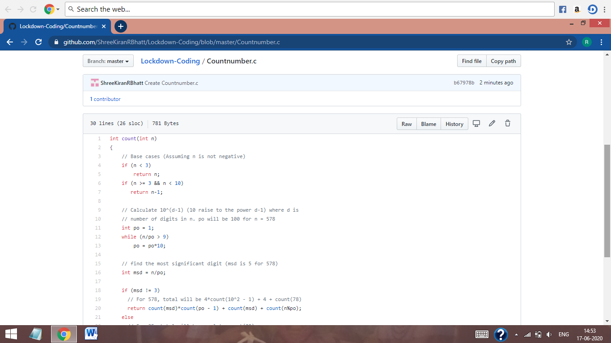

This is the snap shot of my Github repository were I have uploaded the code. File name is Countnumber.c